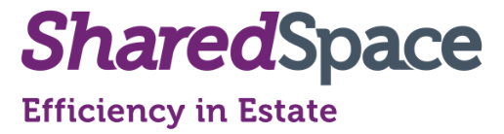
SharedSpace:
The Intelligent Space Management Tool
A live booking and space management tool to improve access and marketability of space combining active monitoring providing effective reports increasing utilisation and savings/ revenue opportunities
Methodology

Key Elements
Increase Access
- Easy to use, modern and intuitive platform for users to access and book space.
- Increase use of space by correctly advertising both internally and externally

Monitoring and data gathering
- Discrete sensors detect motion to understand how spaces are used.
- Data from both sensors and booking system collected
Analysis, reports and results
- Data is analysed and reports are produced to help understand space trends, under/over utilisation, billing reports
- Increase utilisation and save money/ increase revenue.
Data and reports – Key to supporting change, increasing utilisation, savings and revenue.

User-friendly, informative and intuitive

Albion Mills
Albion Lane
Willerby
East Yorkshire
HU10 6DN
Twitter: @SASCityCare
Linked In: Citycare and Shared Agenda
www.citycare-sharedagenda.co.uk
01482 974333

